**Pizza Sales Exploratory Data Analysis (EDA) Report**

**Email: [anilahayat2006@gmail.com](mailto:anilahayat2006@gmail.com)**

**Tableau Public Link: <https://public.tableau.com/views/datavisulazationproject/PIZZASALEREPORT?:language=en-GB&publish=yes&:sid=&:redirect=auth&:display_count=n&:origin=viz_share_link>**

**1. Introduction**

The dataset under analysis contains information about pizza sales, including key metrics like total revenue, order volumes, pizza sizes, categories (Classic, Supreme, Chicken, Veggie), and time-series data. The objective of this EDA is to uncover insights into sales performance across different time periods, pizza sizes, and categories, thereby supporting better business decision-making. The insights gained from this EDA will also serve as a foundation for future AI/ML tasks such as sales forecasting, customer segmentation, and inventory optimization.

**Objectives:**

- To understand the distribution of sales across pizza categories and sizes.

- To identify hourly and weekly trends in sales volumes.

- To extract actionable insights for optimizing inventory management, pricing strategies, and promotions.

- To establish a basis for future predictive models that could enhance sales and operational efficiency.

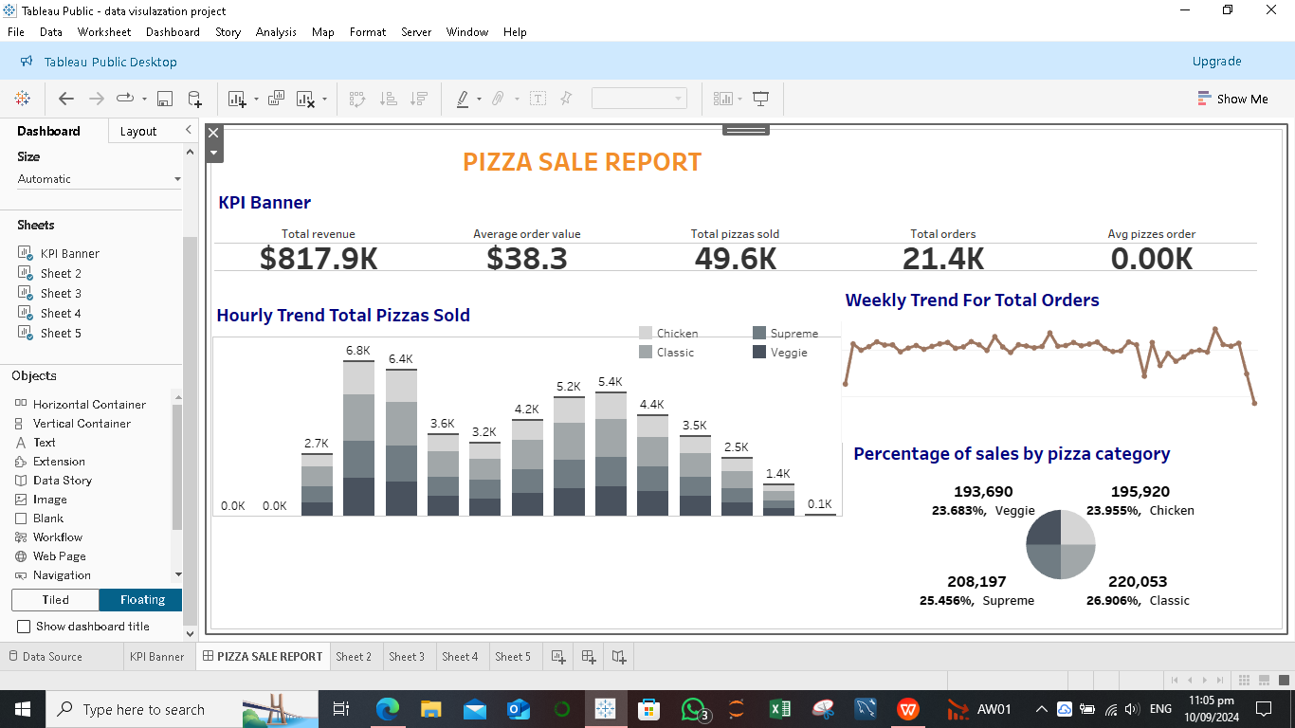

**2. Visualization Process**

**KPI Banner:**

- Metrics Displayed: Total revenue ($817.9K), average order value ($38.3), total pizzas sold (49.6K), and total orders (21.4K).

- Purpose: To provide a quick snapshot of the business's overall performance. The KPI banner was chosen for its simplicity and ability to summarize key metrics in an easily digestible format.

**Hourly Trend for Total Pizzas Sold:**

- Visualization Type: Stacked Bar Chart.

- **Rationale:** A bar chart was chosen to clearly visualize pizza sales for each hour, broken down by pizza category. It highlights peak sales hours (with 6.8K and 6.4K pizzas sold during the busiest hours) and helps identify low-demand periods.

**- Insight**: The business experiences distinct sales spikes during specific hours, which suggests opportunities for optimizing staffing, ingredient preparation, and promotional timing.

**Percentage of Sales by Pizza Size:**

-**Visualization Type: Circle Plot.**

**- Rationale:** This plot effectively illustrates the proportion of sales by pizza size (regular, medium, large, X-large, and XX-large), offering a clear view of customer preferences.

**- Insight:** Regular-sized pizzas dominate sales, indicating a preference for smaller sizes. Promotions targeting larger pizza sizes could increase average order value.

**Weekly Trend for Total Orders:**

**- Visualization Type: Line Graph.**

- **Rationale:** A line graph was selected to visualize the fluctuation of orders over the week. It is useful for identifying trends, dips, and spikes in sales on specific days.

- **Insight:** Sales are relatively stable but experience significant dips at certain points. These dips could represent opportunities to introduce targeted promotions to maintain consistent order volumes.

**Percentage of Sales by Pizza Category**:

- **Visualization Type: Pie Chart.**

- **Rationale**: A pie chart was used to illustrate the proportion of sales across pizza categories (Classic, Supreme, Chicken, Veggie). It offers a clear visual representation of how each category contributes to total sales.

**- Insight:** Classic pizzas account for the largest share (26.91%), while Veggie pizzas hold the smallest share (23.68%). This information can guide menu optimization and marketing efforts, encouraging growth in lower-performing categories.

**3. Decision-Making Justification**

**Design Choices:**

**- KPI Banner:** The banner’s design was focused on simplicity and clarity, ensuring key performance indicators (KPIs) are immediately visible to decision-makers.

**- Color Coding:** A distinct color palette was used to differentiate pizza categories, making it easy to identify trends and proportions across various charts.

**- Chart Selections:** The bar chart for hourly trends and the line graph for weekly trends were chosen for their ability to showcase time-series data effectively. The pie chart was ideal for illustrating category proportions, while the circle plot clearly visualized differences in pizza size sales.

**- Interactivity:** Filters for pizza sizes and categories were added to enable users to explore the data in more detail, allowing for deeper insights without overwhelming the initial dashboard view.

**Clarity, Aesthetics, and Interactivity:**

The design ensures that each visualization is not only clear but also aesthetically pleasing. Interactivity was prioritized, allowing the user to drill down into specific data segments (e.g., sales by category or size) for better decision-making. Overall, the dashboard is intuitive and user-friendly, making it accessible to both technical and non-technical stakeholders.

**4. Challenges and Solutions**

**Challenges:**

- **Data Cleaning:** One of the primary challenges was ensuring the dataset was free of inconsistencies and missing values, particularly in fields like order timestamps and pizza sizes. Incorrect or incomplete data could distort the analysis.

- **Handling Time-Series Data:** Managing time-series data for hourly and weekly trends required careful handling of timestamp fields to ensure accuracy in visualizing trends.

**Solutions:**

**- Data Transformation:** In cases where missing data was encountered, I employed data imputation techniques to fill in gaps. For timestamp data, I used Tableau’s built-in date-time functions to aggregate sales into hourly and weekly buckets.

- **Alternate Visualization Techniques:** When initial visualizations didn’t convey the message clearly (e.g., complex bar charts for categories), I opted for simpler, more effective alternatives like pie charts and circle plots.

**5. Conclusion**

**This EDA provides valuable insights into the pizza sales performance:**

**-Key insights**: Regular pizzas are the most popular, and Classic pizzas account for the largest share of category sales. There are clear peak hours for sales, and certain times of the week see dips in order volumes.

**- Actionable Recommendations:**

- **Inventory and Staffing**: Focus resources during peak hours and reduce overhead during slow periods.

- **Targeted Promotions:** Offer discounts or bundle deals for larger pizzas and categories like Veggie to boost underperforming segments.

- **Marketing Strategy**: Invest in campaigns that highlight the best-selling items while pushing underrepresented categories.